General Chemistry 2 Quarter 1- Module 3 Properties of Liquids and Intermolecular

Forces

Millano, Rei Benedict L. 12-Laplace 8-24-2022

**Pre-test**

1. A 2. B 3. A 4. B 5. D

**Elicit**

1. What phase of matter does this illustration represent? Liquid
2. Why are the particles of the substance very far from each other? Because the particles in the liquid are constantly moving and colliding causing it to be some distance away. But it really only is a representation

|  |  |
| --- | --- |
| Prediction | Explanation |
| It will float | Because the pressure of the water below is greater than the weight of the paper clip. Also, the surface tension is stronger |
| Syrup | Because it is more viscous than the two. |
| Hot water | Because vapor buildup will rush out of the bottle causing some slight air pressure changes making some sounds |
| It starts to melt then transitions to boil | the temperature at which the vapor pressure of the liquid is equal  to the atmospheric pressure. |
| Alcohol | Because it turns into vapor more rapidly compared to water when heat from your hand is in contact making you cooler |

1. How will you describe the intermolecular forces of the particles? Most intermolecular forces are the result of net charge of individual molecules and compounds being attracted to one another forming weaker but relevant bonds. Surface tension is a result of intermolecular forces

**Engage Explore**

1. Surface Tension
2. Viscosity
3. Boiling Point
4. Vapor Pressure

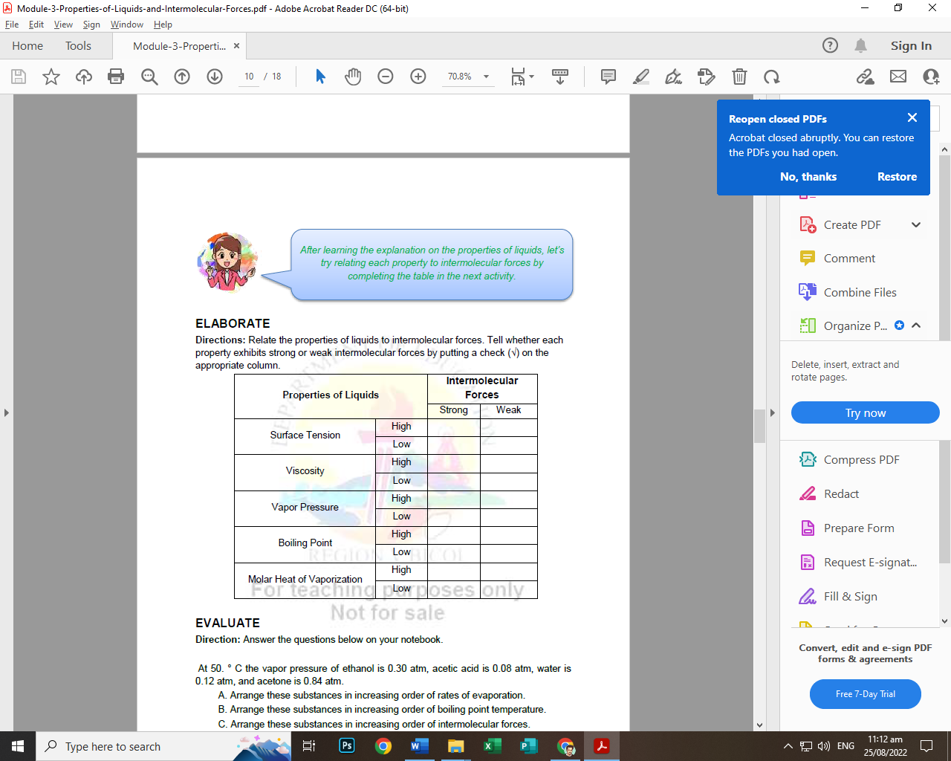

**EVALUATE POST TEST**

1. B
2. A
3. B
4. C
5. B

A. Acetic Acid, Water, Ethanol, Acetone

B. Acetone, Ethanol, Water, Acetic Acid

C. Acetone, Ethanol, Water, Acetic Acid